Problem 14（易）
Prime factorization of n!

The factorials grow very rapidly. Such large numbers can be represented by their prime factorizations. For example,
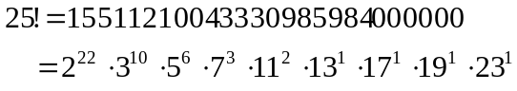
may be represented by
(22 10 6 3 2 1 1 1 1)
i.e. the list of exponents of the primes 2, 3, 5, 7, 11, 13, 17, 19, 23, in that order.

Given an unsigned integer n ≥ 2, your problem is to factor n! into primes according to the following theorem:

THEOREM The prime p is a divisor of n! with the multiplicity
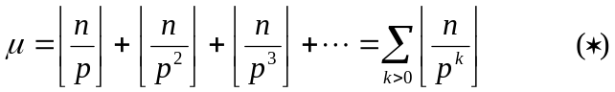

For example, if n = 25 and p = 2, we have
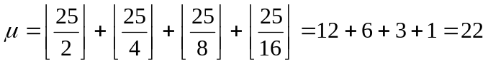
So 25! is divisible by 2²² but not by 2²³.

Although formula  is written as an infinite sum, it is really finite for any particular values of n and p, since all of the terms are eventually zero.
Input
The input consists of multiple datasets, followed by a line which contains only a single ‘.’ (period). Each dataset consists of a single line which contains an unsigned integer. Each unsigned integer is greater than one and less than or equal to 5000 (and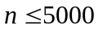).

Output
For each input unsigned integer n, print n!= first. Then print the list of exponents of primes in that order and the list is enclosed by (). Any two adjacent exponents in the list are separated with space.

Sample Input
25
500
.
Sample Output for the Sample Input
25! = (22 10 6 3 2 1 1 1 1)
500! = (494 247 124 82 49 40 30 27 21 17 16 13 12 11 10 9 8 8 7 7 6 6 6 5 5 4 4 4 4 4 3 3 3 3 3 3 3 3 2 2 2 2 2 2 2 2 2 2 2 2 2 2 2 1 1 1 1 1 1 1 1 1 1 1 1 1 1 1 1 1 1 1 1 1 1 1 1 1 1 1 1 1 1 1 1 1 1 1 1 1 1 1 1 1 1)

All inputs are from stdin and outputs to stdout.

